**Work Planning and Control**

Work planning and control (WPC) is the use of formal, documented processes for identifying and mitigating risks when planning, authorizing, releasing, and performing work. The purpose of WPC is to ensure adequate protection of workers, the public, and the environment, which would otherwise be put at risk by inconsistent and inadequate planning, authorization, and control.

This program covers all activity-level work performed in or on facilities managed by SLAC, including technical and administrative activities, construction, experiments, operations, maintenance, and service. It does not cover project management, scheduling, or budgeting. The program also covers the stop work process as part of performing work within controls. It does not cover project management, scheduling, or budgeting.

It applies to all workers (including SLAC employees, subcontractors, and users), supervisors, field construction and service managers and points of contact, project managers, subcontractors, area and building managers, ESH coordinators, department and division heads, associated laboratory directors, the chief safety officer, ESH, and the work planning and control program manager.

**TYPES OF WORK CONTROL TECHNIQUES**

**1. Activity Diagram**

Activity diagram is basically **a flowchart to represent the flow from one activity to another activity**. The activity can be described as an operation of the system. The control flow is drawn from one operation to another.

**Benefits of activity diagrams**

Activity diagrams present a number of benefits to users. Consider creating an activity diagram to:

* Demonstrate the logic of an algorithm.
* Describe the steps performed in a UML use case.
* Illustrate a business process or workflow between users and the system.
* Simplify and improve any process by clarifying complicated use cases.
* Model software architecture elements, such as method, function, and operation.

Activity diagrams map out process flows in a way that's easy to understand. Consider the two examples below when it comes to creating UML activity diagrams.

**When to Use Activity Diagram**

Activity Diagrams describe how activities are coordinated to provide a service which can be at different levels of abstraction. Typically, an event needs to be achieved by some operations, particularly where the operation is intended to achieve a number of different things that require coordination, or how the events in a single use case relate to one another, in particular, use cases where activities may overlap and require coordination. It is also suitable for modeling how a collection of use cases coordinate to represent business workflows

1. Identify candidate use cases, through the examination of business workflows
2. Identify pre- and post-conditions (the context) for use cases
3. Model workflows between/within use cases
4. When to Use Activity Diagram

**Activity Diagram - Modeling a Word Processor**

The activity diagram example below describes the workflow for a word process to create a document through the following steps:

* Open the word processing package.
* Create a file.
* Save the file under a unique name within its directory.
* Type the document.
* If graphics are necessary, open the graphics package, create the graphics, and paste the graphics into the document.
* If a spreadsheet is necessary, open the spreadsheet package, create the spreadsheet, and paste the spreadsheet into the document.
* Save the file.
* Print a hard copy of the document.
* Exit the word processing package.

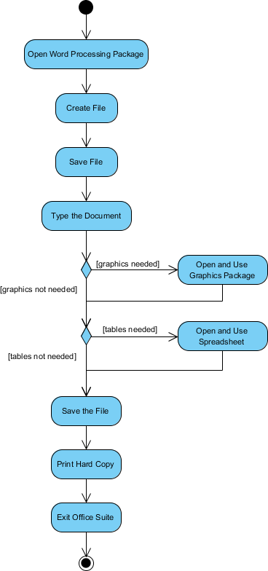

**2. GANTT CHART**

Gantt charts are **visual representations of tasks plotted against time**. They represent crucial information in a project, such as who is assigned to what, task durations, and overlapping activities. A Gantt chart depicts the completion of each work in a project using timelines.

Gantt charts **help you organize projects, improve overall project visibility, and keep everyone on track**. Gantt charts also help managers provide resources when and where they need them. And they encourage collaboration among project team members.

Gantt charts **help you organize projects, improve overall project visibility, and keep everyone on track**. Gantt charts also help managers provide resources when and where they need them. And they encourage collaboration among project team members.

**3. Bar Chart**. A bar chart uses horizontal bars **to represent relationships or changes over time**. In the example shown below, each bar represents a company's sales. This chart allows the viewer to quickly see the relationship between sales of each company

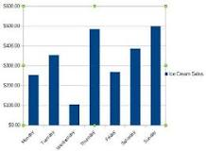

**Advantages of a Bar Graph.**

1. Display relative numbers or proportions of multiple categories
2. Summarize a large amount of [data](https://geographypoint.com/2018/09/advantages-of-observation-as-data-collection-tool-in-research/) in a visual, easily interpretable form
3. Make trends easier to highlight than tables do
4. it helps in studying patterns over long period of time
5. It is used to compare data sets. data sets are independent of each other
6. Most widely used method of data representation. therefore, it is used by various industries
7. Estimates can be made quickly and accurately
8. Permit visual guidance on accuracy and reasonableness of calculations
9. Accessible to a wide audience
10. Can easily compare two or three data sets.

**4. PERT CHART**

A program evaluation review technique (PERT) chart is a graphical representation of a project's timeline that displays all of the individual tasks necessary to complete the project.  As a [project management](https://www.investopedia.com/terms/p/project-management.asp) tool, the PERT chart is often preferred to the Gantt chart because it identifies task dependencies. However, a PERT chart can be more difficult to interpret.

A project manager creates a PERT chart in order to analyze all of a project's tasks while estimating the amount of time required to complete each one. Using this information, the project manager can estimate the minimum amount of time required to complete the entire project.

This information also helps the manager develop a [project budget](https://www.investopedia.com/terms/b/budget.asp) and determine the resources needed to accomplish the project.

**Advantages**

1. A PERT chart allows a manager to evaluate the time and resources necessary to complete a project. It also allows the manager to track [required assets](https://www.investopedia.com/terms/c/core-assets.asp) during any stage of production in the course of the project.2
2. PERT analysis incorporates data and information supplied by a number of departments. This combining of information encourages department responsibility and identifies all responsible parties across the organization.
3. It also improves communication during the project and it allows an organization to commit to projects that are relevant to its strategic positioning.2
4. Finally, PERT charts are useful input for [what-if analyses](https://www.investopedia.com/terms/s/sensitivityanalysis.asp). Understanding the possibilities concerning the flow of project resources and milestones allows management to achieve the most efficient and useful project path.2

**Disadvantages**

1. The information that goes into a PERT chart can be highly subjective. They may include unreliable data or unreasonable estimates for cost or time.
2. PERT charts are deadline-focused and might not fully communicate the [financial positioning](https://www.investopedia.com/articles/fundamental/04/063004.asp) of a project.
3. Creating a PERT chart is labor-intensive, and maintaining and updating the information requires additional time and resources. Continual review of the information provided, as well as the prospective positioning of the project, is required for a PERT chart to be of value.

**PERT Chart vs. Gantt Chart**

Early versions of the Gantt chart did not show dependencies. That is, it didn't indicate where a delay in completion of one task could hold up the start of another task, potentially throwing a whole project off schedule. Later versions of Gantt corrected this.

Some say that a PERT chart makes it easier to see and track a project's critical path. The critical path is the minimum time it will take to complete a project, based on the longest path from start to finish. Some project managers prefer to use a PERT chart as part of the planning stage of a project and a Gantt chart to monitor its execution.